callback hell

**Promise** has been introduced to avoid callback hell

eg: You have made a promise to your friend that tomorrow at 11am you will give him/her a treat

till 11 am of next day promise will be in pending state

now it is 11 am of the next

at this same moment the promise will be executed

1. either promise has been fulfilled (if task has been successfully

completed)

2. or promise has been rejected (if there is an error while

performing any task)

Promise will have 3 states:

1. resolved

2. rejected

3. pending

Based on promise state we can take suitable actions

p1

p2

p3

> we just have to create a promise for any task

when we are creating a promise, its the developer's **responsibility** to resolve or to reject the promise

> after creation we have to execute the promise

> after execution, promise state will become either resolved or rejected

> Based on promise state we can take suitable actions(promise handling )

we have to handle the promise

for ex. Student s=new Student();

var myPromise = new Promise (()=>{});

()=>{} EXECUTER FUNCTION

executor function will have access to the promise states i.e.

resolve and reject

return new Promise((resolve,reject)=>{

});

> note: Promise constructor will take a callback function

as argument and that callback function will contain

the statements that we have to execute for the promise

we need to write whole logic inside the callback function

this callback is known as promise executor function

executor function will have access to the promise states i.e.

resolve and reject

eg: I am promising that every number is going to be an even

number

var evenPromise=new Promise((resolve,reject)=>{

var n=6;

if(n%2==0){

resolve();

}

else{

reject();

}

});

two function to handle the promise

then() -> when promise is resolved

catch() -> when promise is rejected

var evenPromise=new Promise((resolve,reject)=>{

var n=7;

if(n%2==0){

resolve();

}

else{

reject();

}

});

evenPromise

.then(()=>{

console.log("Promise is resolved and number is even");

}).catch(()=>{

console.log("OOOPS! Promise is rejected and number is not even");

});

--------------------------------------------------------------------------------------------------------------------

Spread/ rest operator

function average(...x){

}

average(5,6,7);

average(9,2);

average();

console.log(1,2)

-----------------------------------------------------------------------------------------------------------------

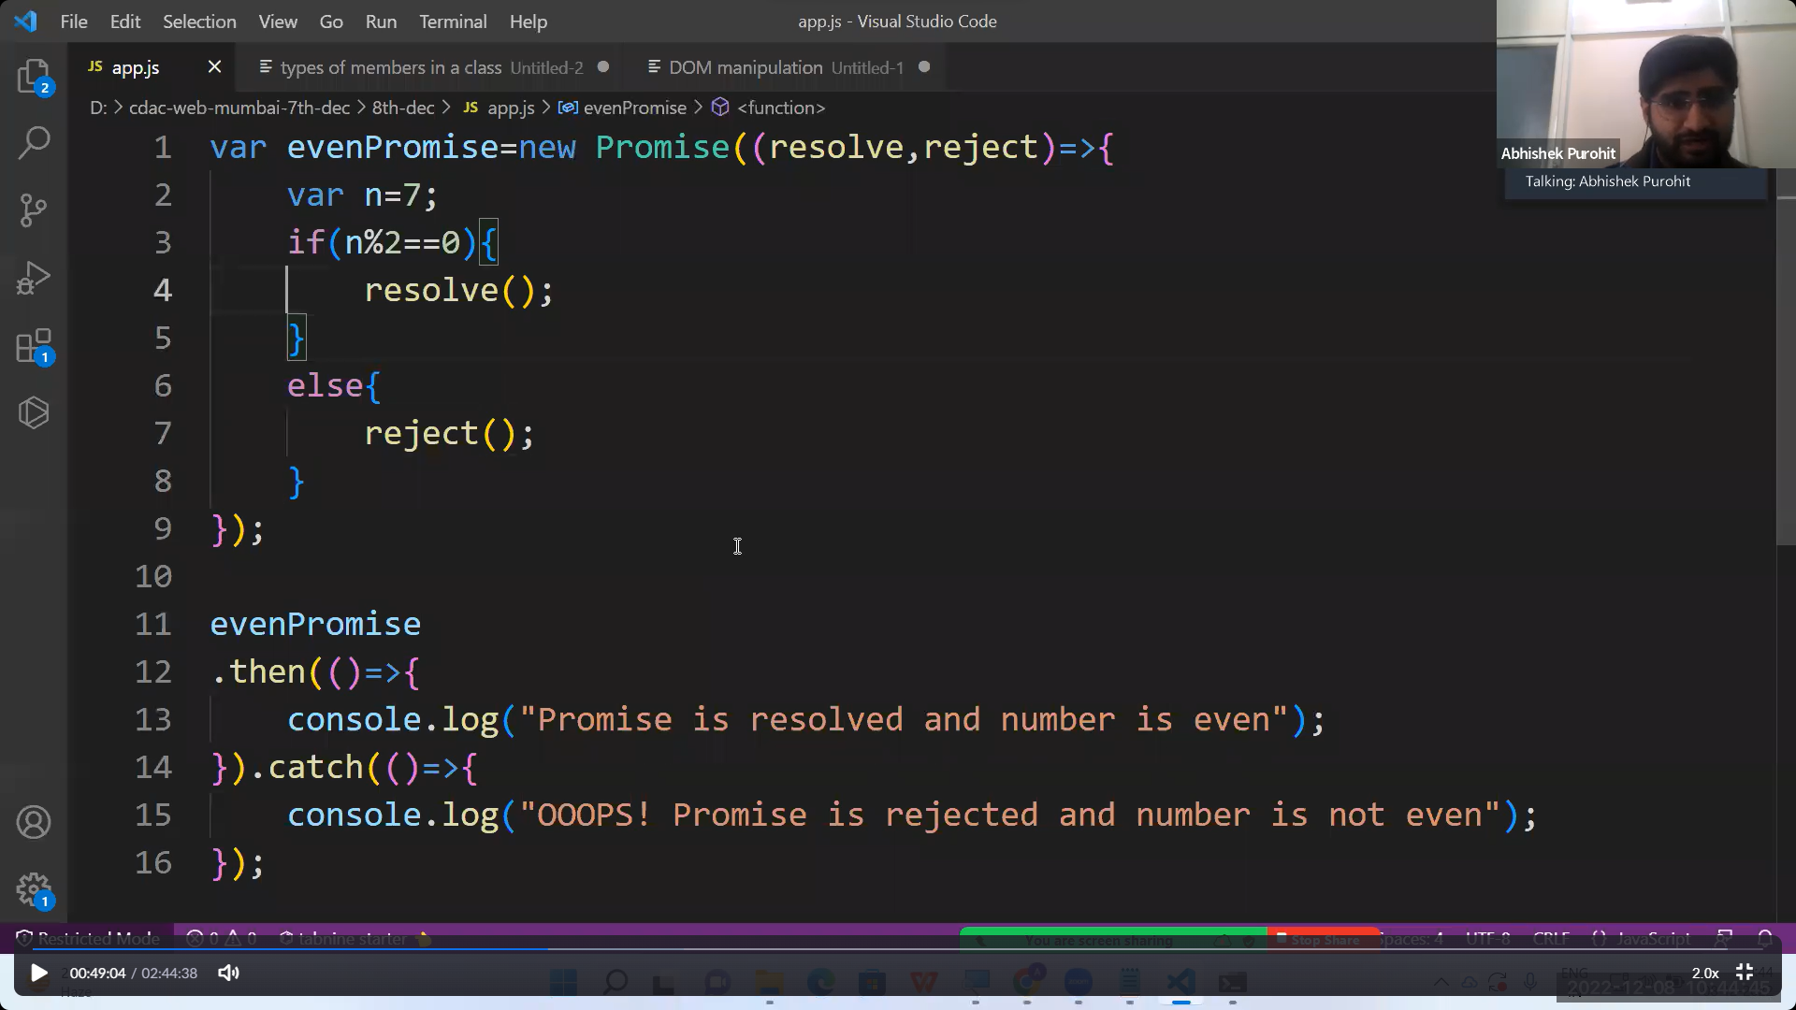

We can pass any argument inside the resolve and reject🡪

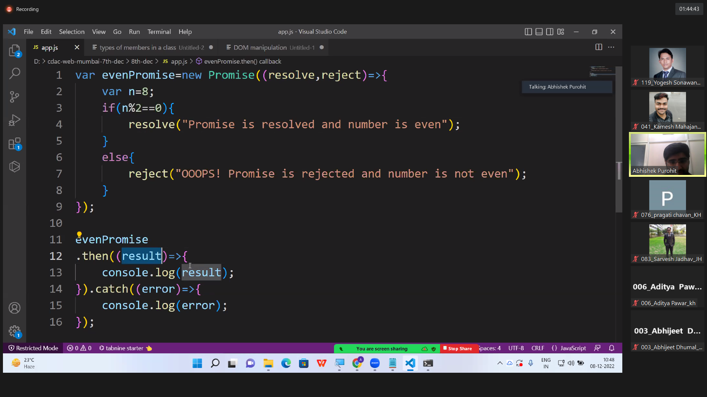

function checkEven(n){

return new Promise((resolve,reject)=>{

if(n%2==0){

resolve([10,20,30,40]);

}

else{

reject("OOOPS! Promise is rejected and number is not even");

}

});

}

checkEven(7)

.then((result)=>{

console.log(result);

}).catch((error)=>{

console.log(error);

})

---------------------------------------------------------------

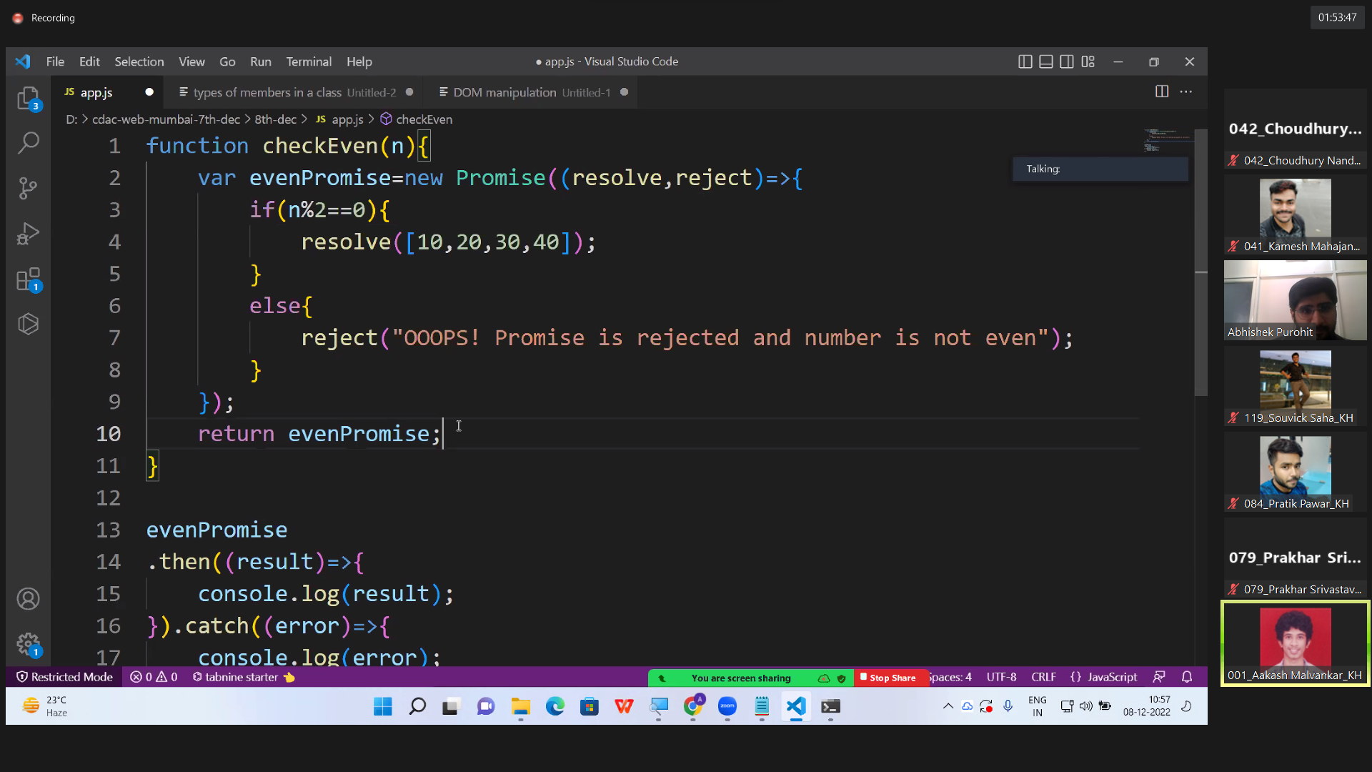

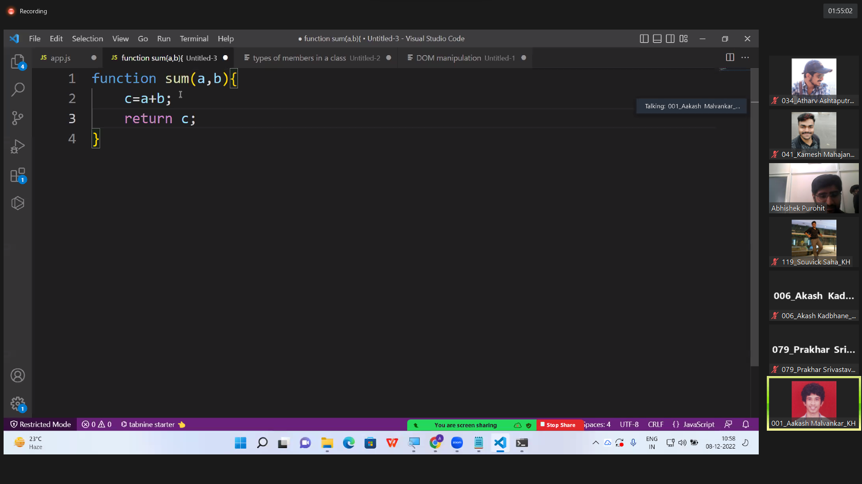

Then we can directly **return a+b just like in above image**

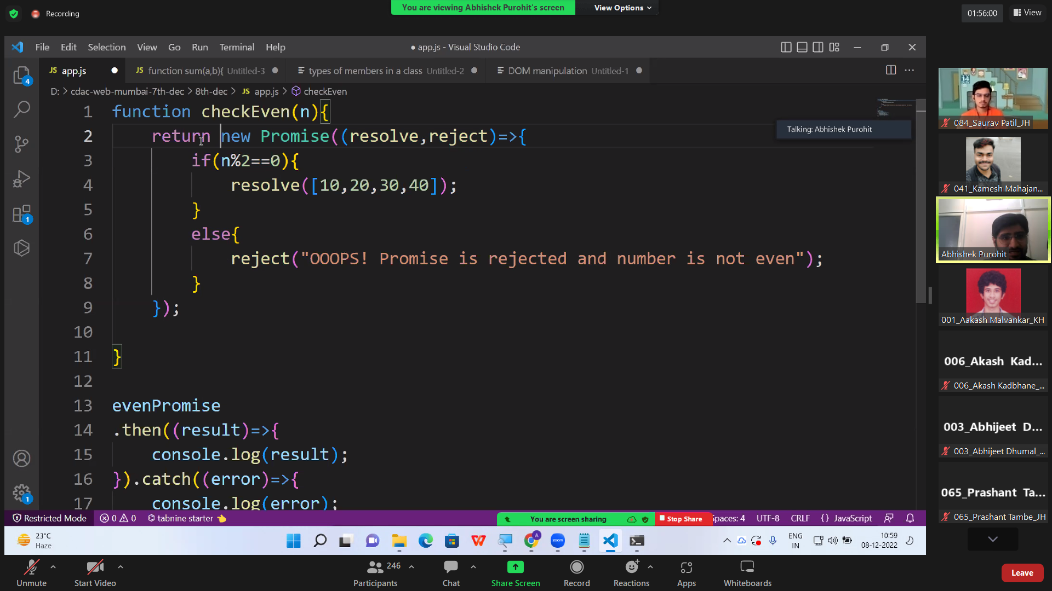

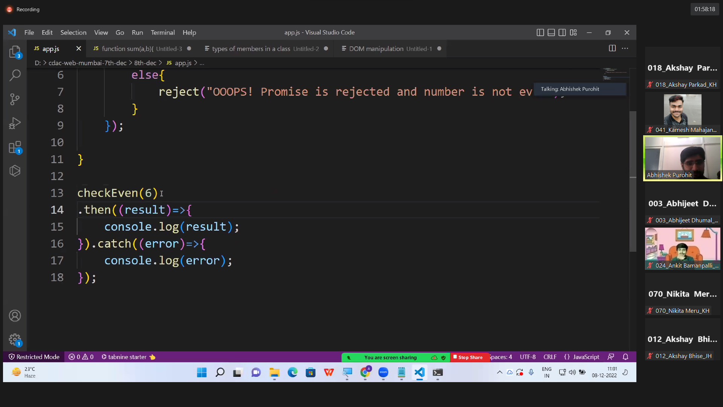

We can directly call checkEvent and pass argument to check whether it is even or odd

Make dynamic input

function sum(a, b) {

return new Promise((resolve, reject) => {

console.log("finding sum...");

setTimeout(() => {

resolve(a + b)

}, 4000)

});

}

function factorial(n) {

return new Promise((resolve, reject) => {

console.log("finding factorial...");

setTimeout(() => {

var f = 1;

for (var i = 1; i <= n; i++) {

f = f * i;

}

resolve(f);

}, 2000);

});

}

function cube(n){

return new Promise((resolve,reject)=>{

console.log("finding cube...");

setTimeout(()=>{

var c=n*n*n;

resolve(c);

}, 3000);

});

}

sum(2,4)

.then((c) => {

Var obj = factorial (c)

Return obj;

console.log("sum is", c);

return factorial(c);

First then returning promise hence second then come into picture,   
hence we’re chaining multiple then, without nesting of callback

})

.then((f)=>{

console.log("factorial is", f);

return cube(f);

Now second then also returning promise hence we’ve to write third then come into picture

})

.then((cubeValue)=>{

console.log("cube is", cubeValue);

})

.catch((error)=>{

console.log(error);

});

Just like this were returning the promise

No of lines are increased but that is without nesting callback function, easy to debug

only one catch function require for all then

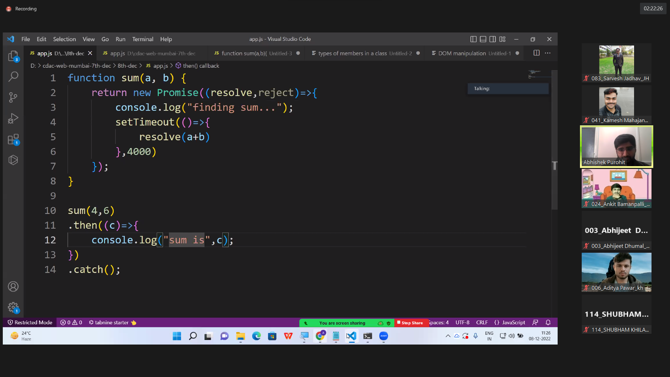

Finding sum..

Sum is 10

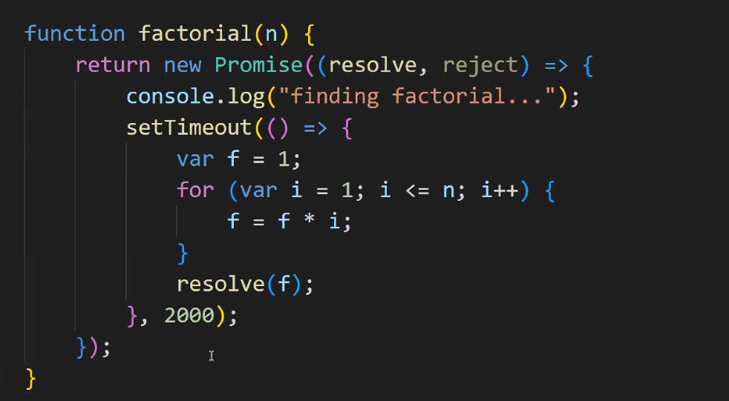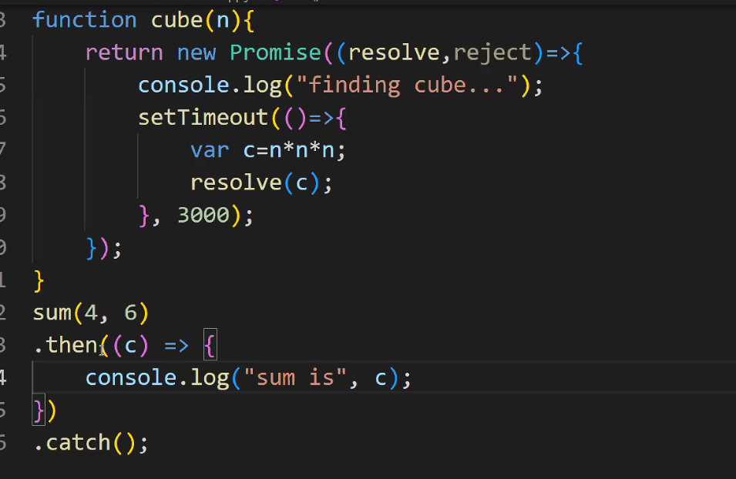

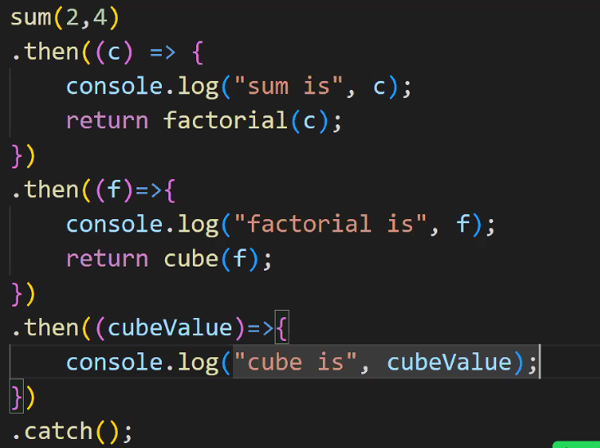

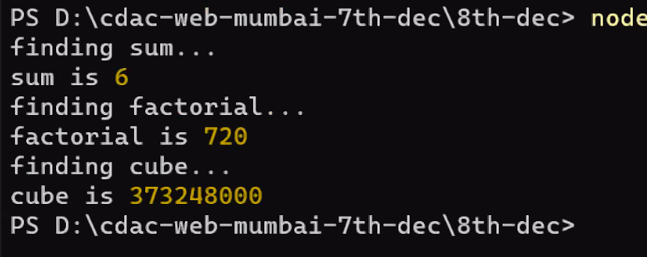

Thus we we can achieve nesting without using callback function

Dummy server

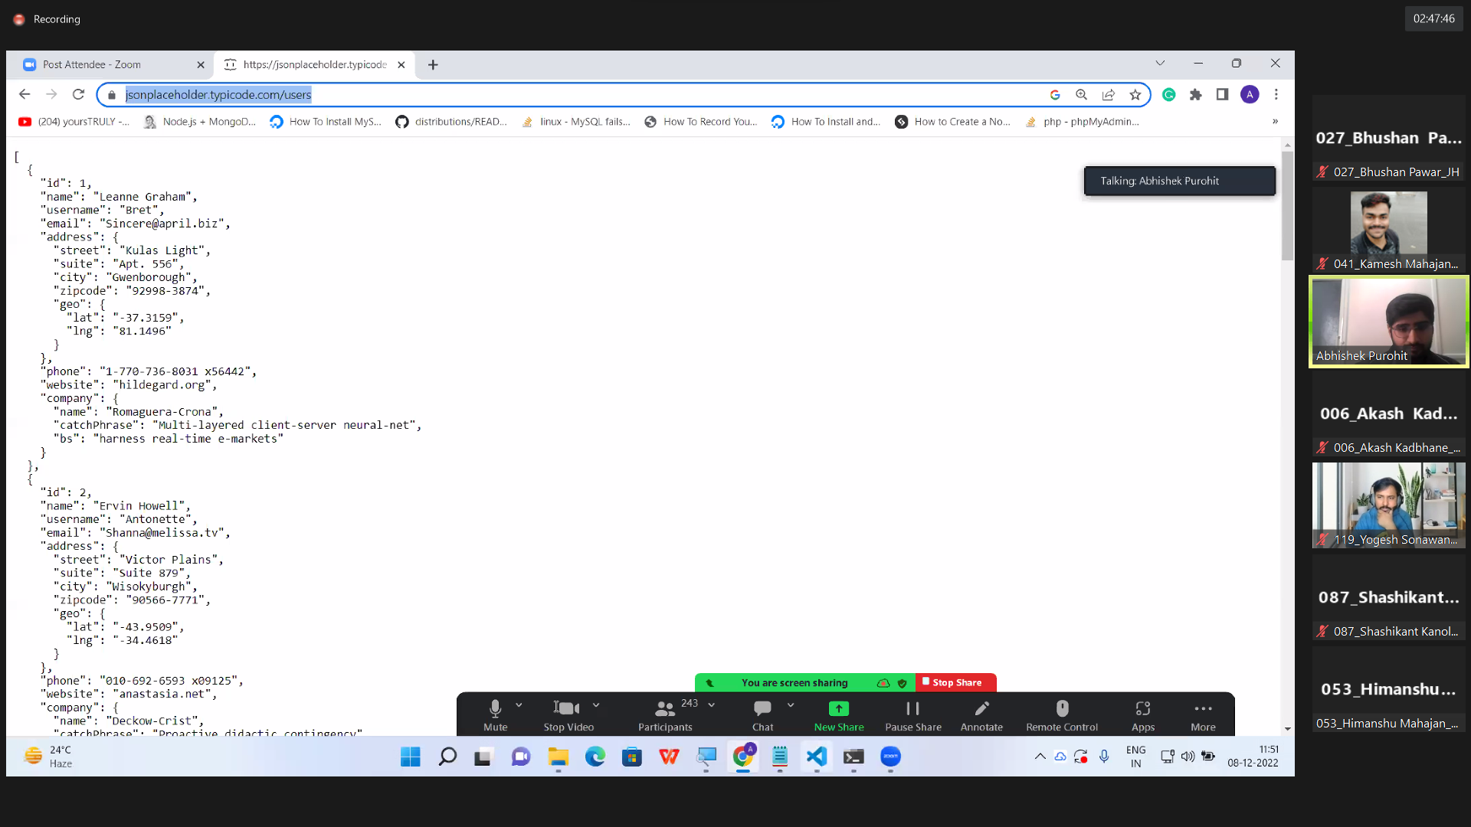

Fetch will retun in form of promise 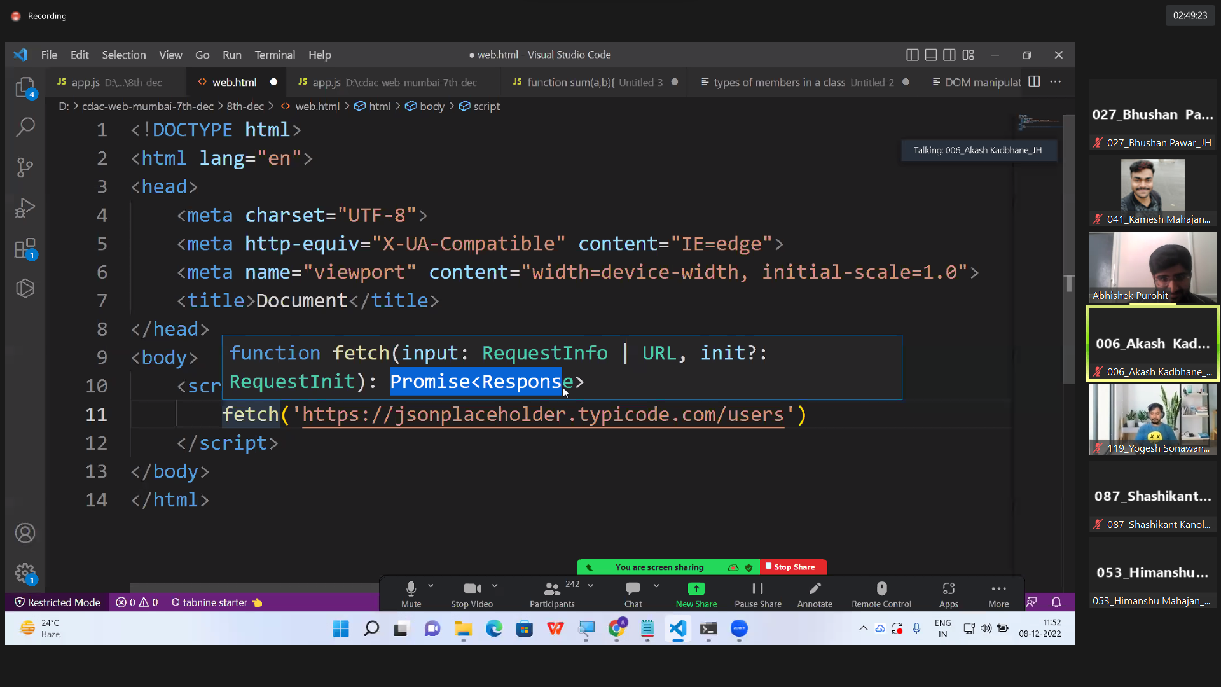

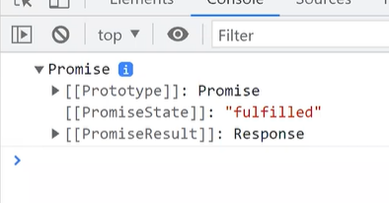

State fulfilled means resolved

Now we have to handle it, and inside then we’ll get server response, if data is successfully feached from link then only then function is executed

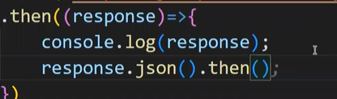

we can do like this also but it will again create callback situation ……

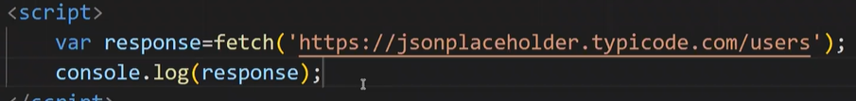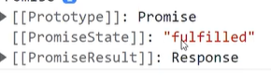

We can do like above also ie response will be fulfilled and directly .then on fetch will also work

We have to handle this promise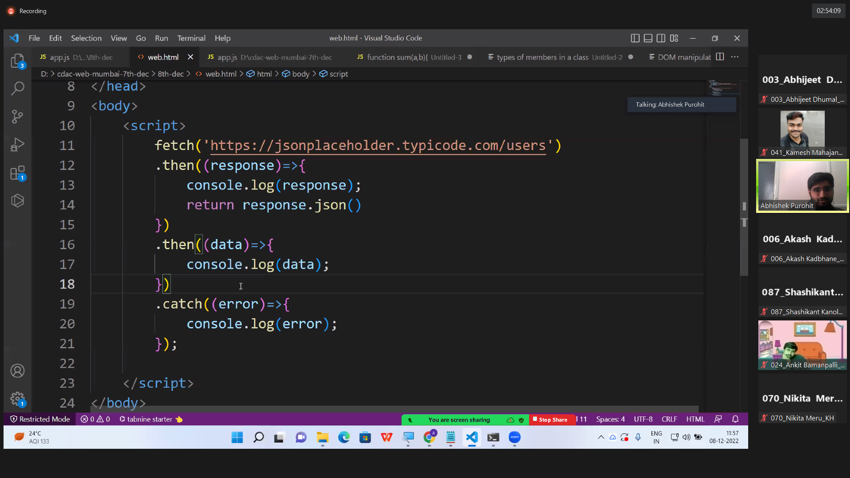

When above promise is getting resolved the that value will come inside response, It will return the json data whch is sent by server. That JSON will return promnise and were further retujrning it

We’ll get that value which is resolved in that promise

1st then resolved, result will give json object

2nd then will give array of JSON object with value,

Fetch function is more eaier than ajex mechanism

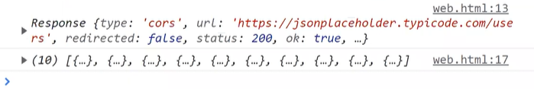

Fetch fun will ajex data

Fetch will return promise, Response into promise work of fetch

That link will give data in form of json object

**Fetch function internally sending ajex request**

fetch()

there are two ways to handle the promise:

1. then() catch() --with promise

2. async await: async and await are the keywords

> await keyword must be placed **inside a function body(**must have function body**)**

(we can't write await keyword **outside** any function body)

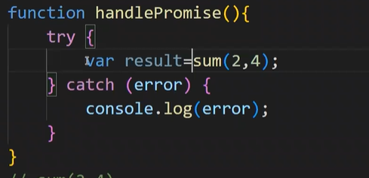

Above result will become promise object

AWAIT keyword will written only on function which will return promise

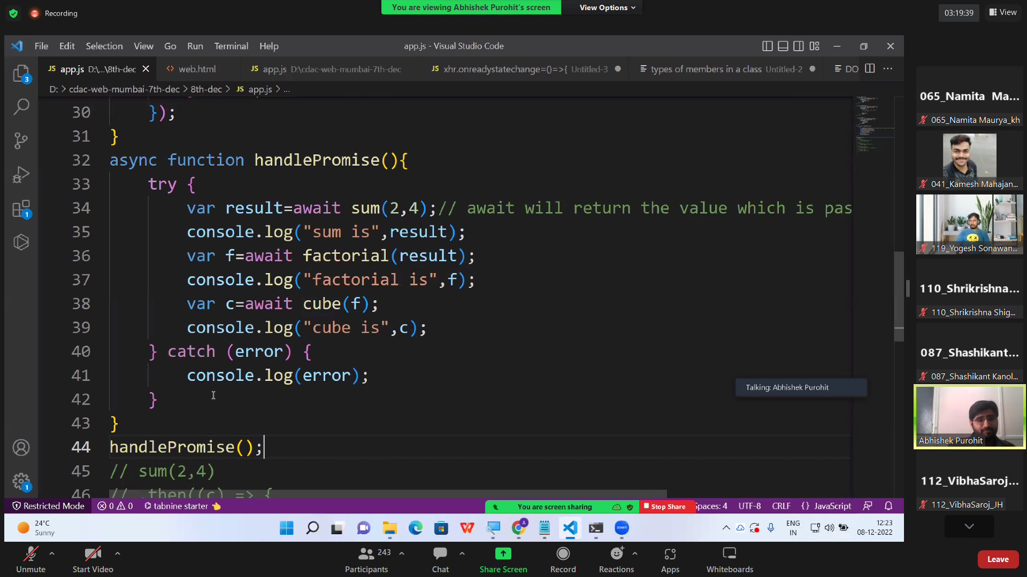

But if we write await then result will assign into variable means here 6 will be stored

a

If we’re calling a function that is returning **promise** on that function write await keyword

It make other statements to wait for until promise has been resolved / rejected

When await keyword is written then thigs will executed synchronously

THIS IS MORE PRECISE WAY TO HANDLE PROMISE THAN ”THEN CATCH”

function sum(a, b) {

return new Promise((resolve, reject) => {

console.log("finding sum...");

setTimeout(() => {

resolve(a + b)

}, 4000)

});

}

function factorial(n) {

return new Promise((resolve, reject) => {

console.log("finding factorial...");

setTimeout(() => {

var f = 1;

for (var i = 1; i <= n; i++) {

f = f * i;

}

resolve(f);

}, 2000);

});

}

function cube(n){

return new Promise((resolve,reject)=>{

console.log("finding cube...");

setTimeout(()=>{

var c=n*n*n;

resolve(c);

}, 3000);

});

}

async function handlePromise(){

try {

var result=await sum(2,4);// await will return the value which is passed inside the resolve

console.log("sum is",result);

var f=await factorial(result);

console.log("factorial is",f);

var c=await cube(f);

console.log("cube is",c);

} catch (error) {

console.log(error);

}

}

handlePromise();

// sum(2,4)

// .then((c) => {

// console.log("sum is", c);

// return factorial(c);

// })

// .then((f)=>{

// console.log("factorial is", f);

// return cube(f);

// })

// .then((cubeValue)=>{

// console.log("cube is", cubeValue);

// })

// .catch((error)=>{

// console.log(error);

// });

-------------------------------------------------------------------------------------------------------------------

Second way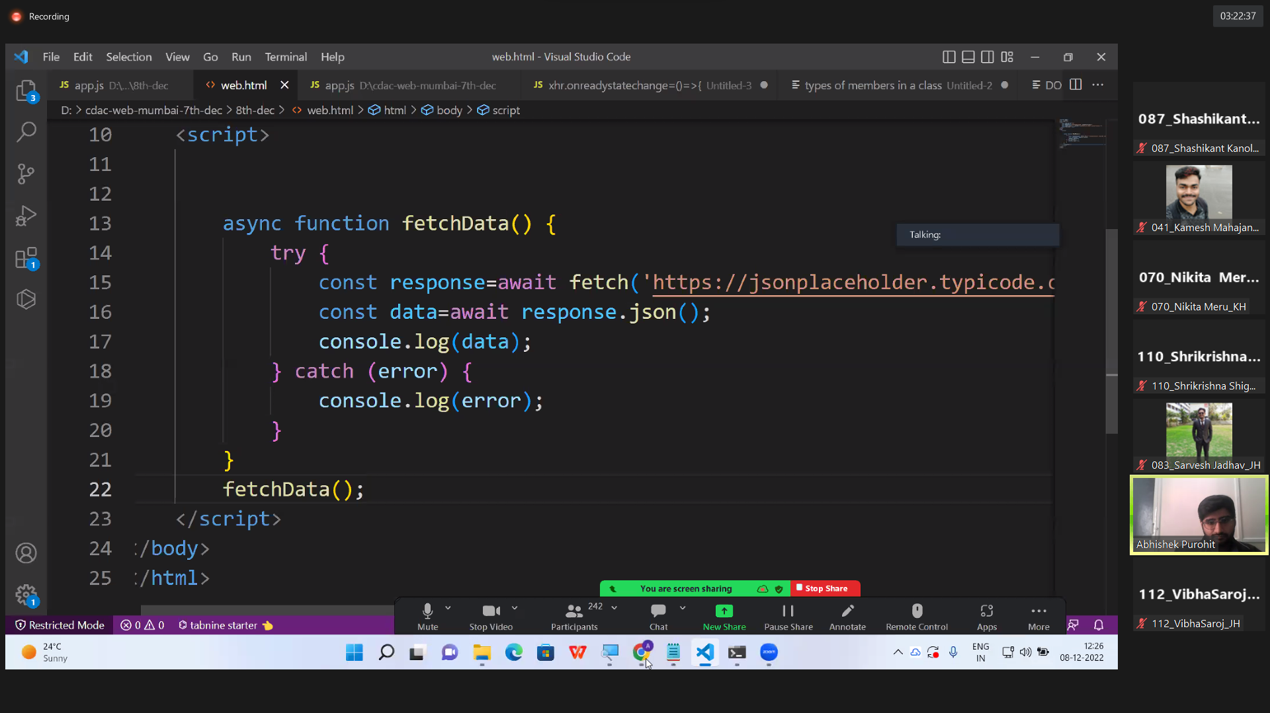

which is better thenCatch or asyncAwait?

When few promises are dependent on each other then async await

But if things are not dependent then we have to use then catch hence they can execute asynchronously

Using Ajex

State of request (what is happening means reqest is procrssing or reached or not, server responding or not )=> readyState property of XHR object recognise current state of our request,

readyState is int value 0 1 2 3 4

AJAX:

process using which we can send a request and get a response

from a server asynchronously

1. create an object of XMLHttpRequest

var xhr=new XMLHttpRequest()

2. initialize the request

mention the url

mention the request method

GET POST PUT DELETE

xhr.open(method,url)

3. send the request

xhr.send()

4. get response from the server

to recognize the current state of the request check READY STATE VALUE

> if request send or not

> if server responded or not

> if server processing the request or not

>if server has sent the response

> if client has received the response

<https://www.tutorialrepublic.com/javascript-tutorial/javascript-ajax.php>

readyState property of xhr object has been introduced

readyState will be an integer

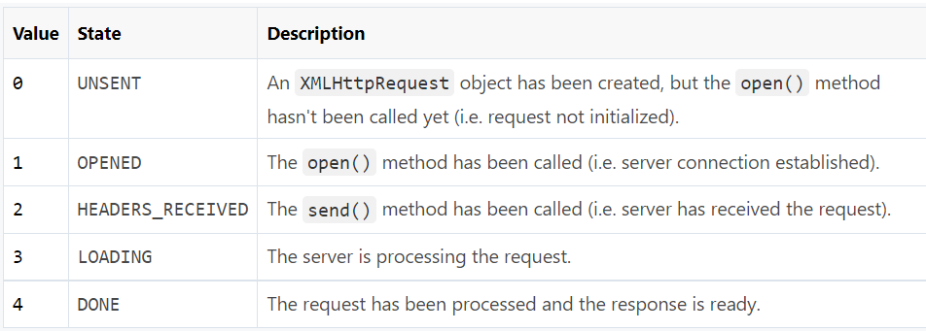

The status property returns the numerical HTTP status code of the XMLHttpRequest's response. Some of the common HTTP **status codes** are listed below:

* 200 — OK. The server successfully processed the request.
* 404 — Not Found. The server can't find the requested page.
* 503 — Service Unavailable. The server is temporarily unavailable.

onreadystatechange-----whenever ready state is going to change then(onreadystatechange this event will fire) this callback function will executed()

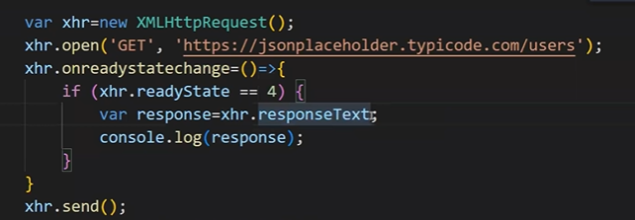

It will give JSON object but in form of string

Response will be in JSON format but it will displayed like string

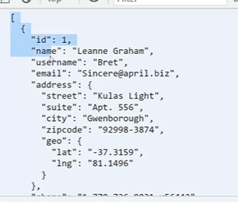it will give array of JSON objects but as string

For extracting this array we have to use JSON.parse

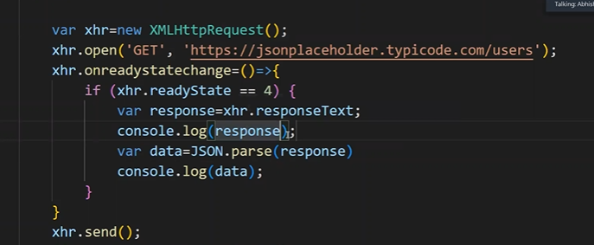

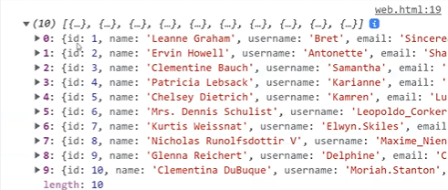

With status code

